**Kickstarter: Ideas to Predict a Successful Campaign**

Elias El Metennani

2/9/2019

**By Category**

The data had Kickstarter campaigns divided into 9 parent categories. Some conclusions from analyzing these categories:

1. Theater was by far the most prevalent category people tried to raise money for
2. Projects under Music had the best chance of success
3. Projects under Technology and Journalism had the highest rates of being cancelled

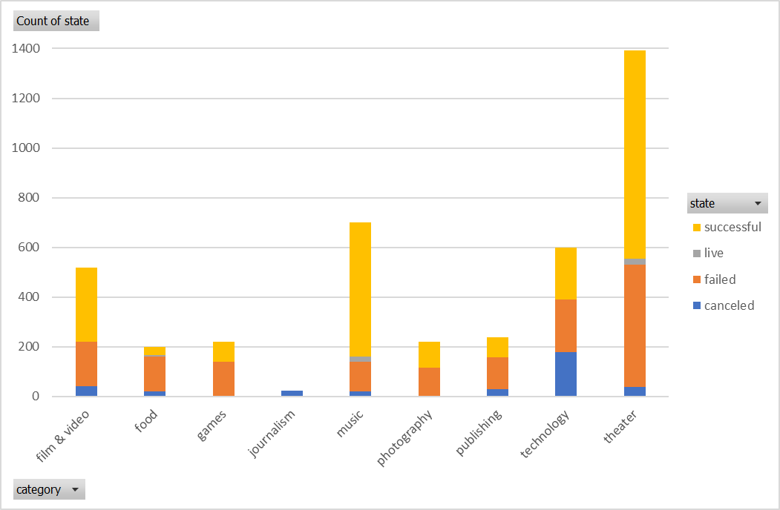

**By Subcategory**

There are 41 subcategories that fall under the parent categories.

1. Plays were the most popular subcategory
2. Create a project for Rock music, hardware, or a documentary for the best chance of success
3. A project for animation, drama, food trucks, or children’s books usually fails

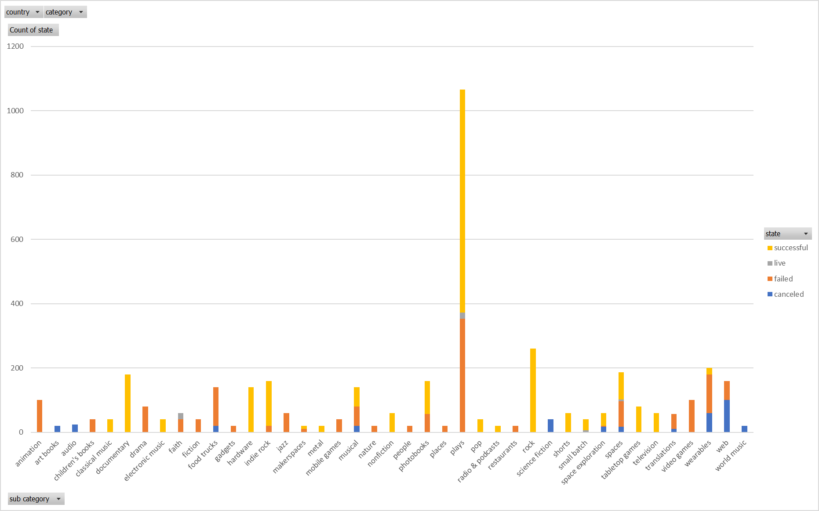

**By Month Launched**

1. Peak success is achieved when launched in May.
2. Cancellation is steady through the calendar year
3. December is the only month in which launching a project is more likely to end in failure than success

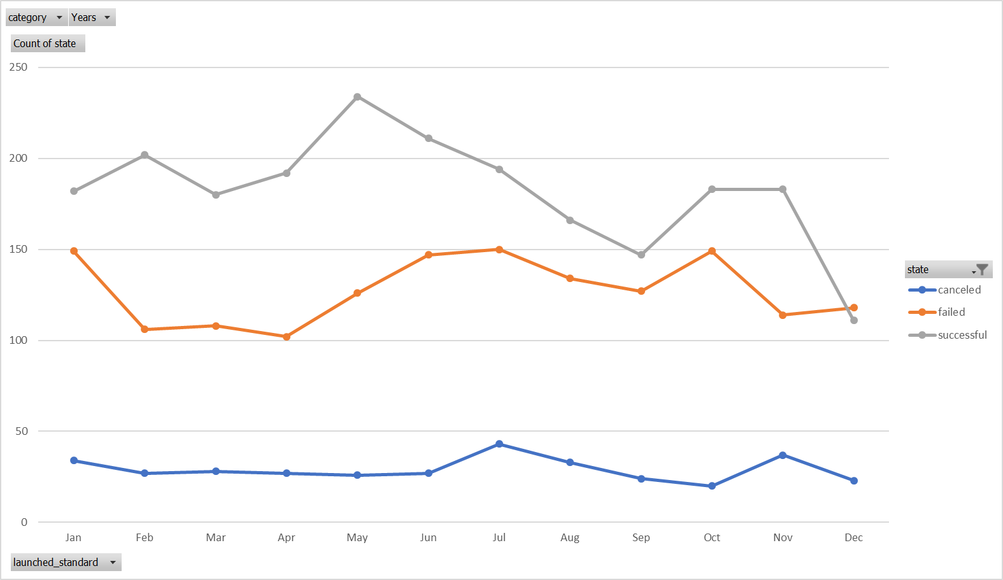

**Limitations**

It would be nice to have certain data such as: inclusion of video in kickstarter campaign, did an individual or company launch the project, what kind of rewards were offered to those who donate. At the surface these seem to be important criterion when determining the success of a project.

**Other Ideas**

Looking at donor count by month, or funding goal vs time for funding could be other high level ways of analyzing this data.